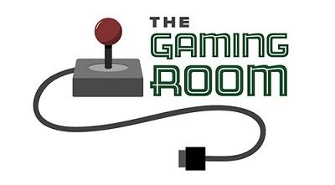

Draw it Or Lose it

CS 230 Project Software Design Template
Version 1.0

Table of Contents

CS 230 Project Software Design Template 1
Table of Contents 2
Document Revision History 2
Executive Summary 3
Requirements 3
Design Constraints 3
System Architecture View 3
Domain Model 3
Evaluation 4
Recommendations 5

Document Revision History

Version | Date | Author | Comments
1.0 | 03/15/2023 | Meharban Singh | Completed the design document

Instructions
Fill in all bracketed information on page one (the cover page), in the Document Revision History table, and below each header. Under each header, remove the bracketed prompt and write your own paragraph response covering the indicated information.

Executive Summary

The client (The Gaming Room) wishes to expand their reach by creating a web based game based off of their android mobile game called Draw it or Lose it. The game should work on different platforms. The problem the client is having is that they do not know how to set up the environment in order to create the web based game. Our job will be to assist The Gaming Room in creating an online environment that they can use to develop the game off of.

Requirements

- The game needs to support one or more teams
- Every team needs multiple players
- Game names need to be unique
- Team names need to be unique
- Users need to be able to check if their team name is in use
- Only one instance of the game can be active in memory at a time

Design Constraints

Several design constraints need to be considered based off of the requirements. First the game needs to work in a web based environment. This means that we need to hire people familiar with web based frameworks such as Node.js and also with common web development languages like C# or Javascript. Second we will need to be able to run the game on multiple different OS platforms, this could be difficult since we will have to make sure that the game needs to be tested on Mac, Windows, Mobile Browsers, and Linux. Each of these will require testing to be done in order to calibrate the game properly and make sure it is working. As a result we might have to hire people who are familiar with different platforms in order to work out any obstacles we come across. We will also need to be able to run the game on multiple different browsers as well. The main three will be Chrome, Firefox, Edge, and Safari. Chrome and Firefox operate on different platforms but Edge (although it can be run on Mac) and Safari are both specific to their OS platforms. We will need to hire testers to make sure there are no bugs in any of these browsers as well as their mobile counterparts. Lastly we will need to take time and budget into account. This will be a large project and will require testing on several different browsers and platforms so coordinating everything and remaining in budget will require strict deadlines and realistic goals.

System Architecture View

Please note: There is nothing required here for these projects, but this section serves as a reminder that describing the system and subsystem architecture present in the application, including physical components or tiers, may be required for other projects. A logical topology of the communication and storage aspects is also necessary to understand the overall architecture and should be provided.

Domain Model

From the UML diagram we can see that the entity class will be extended by the Team, Game, Player classes. This shows inheritance and encapsulation as all of the attributes are private and the classes inherit from Entity. We can also see that the Game Service class has a none to many relationship with game and Game inherits from Entity so this shows inheritance as well. The Program Driver and the Singleton Tester are related as Program Driver uses the Singleton Tester to see if there is only one instance of the game running in memory at any time. Setting up the classes in this manner allows for a modular approach to be taken and can increase efficiency because every class has it’s own attributes and functionality and can be extended based on the project requirements. This allows for the classes to be more readable as well since we know what the purpose of each class is. Lastly we can see that the private attributes help protect the security of the program since each attribute can only be accessed via the getters and setters which leaves the software less vulnerable.

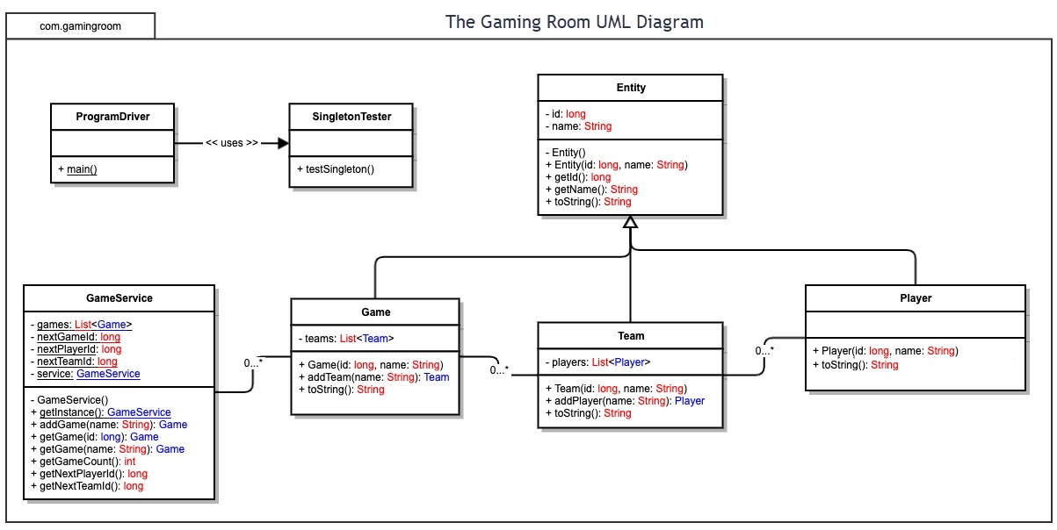

Evaluation

Using your experience to evaluate the characteristics, advantages, and weaknesses of each operating platform (Linux, Mac, and Windows) as well as mobile devices, consider the requirements outlined below and articulate your findings for each. As you complete the table, keep in mind your client’s requirements and look at the situation holistically, as it all has to work together.

In each cell, remove the bracketed prompt and write your own paragraph response covering the indicated information.

Development Requirements | Mac | Linux | Windows | Mobile Devices
Server Side | Mac OS comes with Apache which is it’s own built in web server. In terms of security and reliability Mac would be a great choice since Apple tests macOS extensively on their proprietary machines. A downside is Mac is not very widely used for large scale servers due to the operating cost being rather high. | Linux is open source and freely available which can be very useful when scaling up any operation. Linux can also run a wide variety of software and is one of the most popular OS’s for running servers rivaled only by Windows. Linux is also very secure. A downside is that Linux has a higher learning curve due to the reliance upon commands and terminals instead of GUI. | Windows is widely available and relatively cheap which makes it a great option for server side development. Things like Azure can be used to set up virtual servers which can make setting up and scaling your operations much simpler and easier to maintain. One downside however is that Windows is relatively vulnerable since it is so widely used. | Mobile devices are great in terms of portability but their limited power and performance makes it unusable and inefficient when it comes to server side development. It is not the best option
Client Side | Cost can be a significant hindrance when it comes to development on Mac since it is not as widely used and compatible as Linux or Windows. It can be harder to find developers who specialize in Mac development so this could require both more time and expertise. | Since Linux is free and open source the main consideration to take into account regarding cost is developer expertise. Linux is not as user friendly as something like Windows or Mac so we will need someone who is both good at development and knowledgeable in regards to the Linux OS. | Windows is the most widely used OS in the world and finding developers with enough expertise to work on it will be less difficult than with Mac or Linux. The cost will be higher than Linux but lower than Mac since we will still have to pay for Azure to run the servers. | Development on Android and iOS will require developers who are proficient with both platforms. This will require a good deal of time as well since we will have to test for each OS individually. Another consideration is that it will be more expensive since we will have to find the right people who are proficient with both
Development Tools | Apple has developed their own programming language called Swift which can be used alongside most major coding languages to develop on Mac. In terms of IDE’s Mac uses Xcode which is their own IDE and is integrated into the OS. | All the major languages such as Python, Java, and C++ are supported which makes Linux very flexible. IDE’s like Eclipse and JetBrains are also supported on Linux. Tools such as Junit and Cmake can also be helpful. | Windows is widely compatible with a variety of programming languages like C++ Java, and Python which makes it good for development. On top of that Visual Studio Code and SQL management studio makes handling both back end and development much easier and more integrated. Tools such as Intellisense also help in VS to make coding easier. | For Android the primary coding languages will be Java/Kotlin and Android Studio will the primary IDE. For iOS it will be Swift and the primary IDE will be Xcode. For Android we will require the Android SDK and for iOS we will require the iOS SDK to develop on each platform. Android will require Gradle for the build system as well.

Recommendations

Analyze the characteristics of and techniques specific to various systems architectures and make a recommendation to The Gaming Room. Specifically, address the following:

- Operating Platform: In an ideal scenario, where time, budget, and technical proficiency are not an obstacle I would recommend Linux as the best option overall for a server platform, but since we are limited by the requirements I believe the most well suited option for the client’s use case would be Windows Server 2019 and Azure. The reason I believe that Azure/Windows Server will be the best solution is that it’s centralized UI (Azure Portal and Automation) has the benefit of allowing the client to maintain and control the development of the app in a more easily understood manner. While Azure has additional costs associated with it I believe that this cost will be offset by the relatively intuitive nature of Windows Servers/Azure. If we were to go the Linux route it would require a greater deal of outsourcing due to The Gaming Room’s lack of expertise in server hosting and this would hinder the time frame for development so the most suitable compromise in this case would be Windows Servers.

- Operating Systems Architectures: Since we are using Windows Servers and The Gaming Room may not be able to adequately fund and test a multi tier web based application architecture in the given time it would be best to stick to the simpler two tier client server architecture. As mentioned above we already know that The Gaming Room has limited knowledge in terms of hosting servers and I fear that using a multi tier architecture would again lead to higher consultancy fees, increased testing, and longer development times since we would have to not only implement ever layer of the multi tier we would also have to explain how manage and test these layers to the staff of the Gaming Room, and if something does not work they will again have to reach out to us to fix the issues, which may cause them to go over budget. Therefore a two tier client server architecture model would be the best option considering the limited technical expertise of the client. Once they are able to fully understand the two tier we can consult them further on the multi tier in the future if they wish to do so.

- Storage Management: Using an Azure VM as a storage unit or even Azure storage itself can be the best option since it will already be implemented into the Azure ecosystem and will make compatibility much easier to accomplish. An Azure VM can be scaled up or down relatively easily and the Windows OS on these machines is easy to configure and use due to the intuitive UI and the generally well know nature of Windows OS for the common consumer. Again Linux would be a hindrance here since The Gaming Room would have to read more documentation in order to understand how storage works and that could slow them down.

- Memory Management: We will be running off of Windows Servers and Windows VM’s so deploying and scaling the memory usage will be governed through the Azure portal. If the Gaming Room wishes to increase their memory allotment they can deploy a new VM or increase the current VM’s RAM through the portal in a seamless manner. Furthermore if there are issues with memory we will get alerts from Azure and we can monitor the memory usage and other metrics through the analytics tools provided within each VM’s management console.

- Distributed Systems and Networks: We can use the REST API to make the Distributed System stateless which can make managing the network across several platforms much easier. This will also have the advantage of creating a uniform network that won’t be dependent on the client’s platform to function. We can create a centralized network that will contain all the information needed inside of the requests that are being sent to it and in this way we will not have to rely upon having to tailor the server to the functionalities of each OS that the client might be using. This will heavily cut down on testing time and will make sure that there is a consistent way to communicate between the server and the client without having to devote too much time to testing each platform individually.

- Security: Since we are using the REST API all of the communication will be handled via an interface that will automatically serve as a middleman between the client and the server. In this way we can mitigate some security threats since the client is not directly communicating with the server and cannot modify the server in any way and also vice versa the server cannot modify the client. In this way we can decouple the client and the server and only allow for approved requests that are not store on the server itself which will protect the privacy of the client and ensure further security for the server. Furthermore since we will be using Azure VM’s and Windows Servers we can further enhance server side security through the use of Windows Defender and Firewall which are included with every VM. If we wish to further enhance security we can use Bitlocker to encrypt the data on our servers. Furthermore we can also use Network Security groups that come with each VM to create security rules to govern access to the VM’s. If we wish to make it even more secure we can use something like Always Encrypt included inside of SQL Management Studio to encrypt our database. Another option would be to use something like Windows Active Directory and Group Policies to further secure who can access the server and how often they should change their passwords or even what programs are allowed to run. Overall Windows OS has a lot of security features that we can use to help mitigate vulnerabilities and threats.

